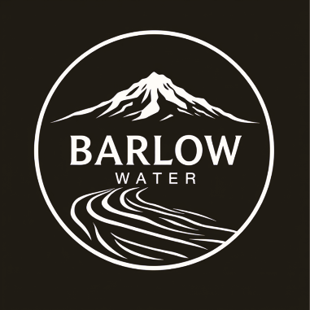

Backflow prevention

Barlow Water Improvement District manages the community cross connection and backflow prevention program to safeguard the community water system.
  - Annual Testing Information

Customer notification: June 2026
Certification due: September 1, 2026
Please have your testing company submit test results to: backflow@barlowwateror.gov

Summer is upon us! Although the season doesn’t officially begin until June 21, many customers began watering in May. Irrigating lawns, combined with summer residents and visitors, has increased our water consumption by 400%. Over the winter, Pine Hollow uses around 1.3 million gallons of water each month. In July, Barlow Water may produce as much as 15 million gallons per month.
When many customers in your neighborhood turn on their sprinklers at the same time, you may notice your water pressure drop. This is normal and does not pose a hazard. However, a sudden large drop in pressure has the potential to cause the flow of water to reverse direction. While it is a rare event, water can be siphoned back into the supply lines if pressure drops too low. Extremely low or negative pressure events can happen when a water main breaks, when several fire hydrants at once are used for firefighting, or when the tower supply drops too low due to equipment failures. (Not lawn watering)
- Backflows occur when there is greater pressure on the customer’s side of the connection than on the supply side (Barlow Water mains), and there is a cross connection between the supply of drinkable (potable) water and water that has already left the system (non-potable). Once water has left the water lines, contaminants could be introduced. For example, if you have a low spot in your yard where a sprinkler head sits, there might be a pool of water around it that is now mixed with fertilizer or other things found in the yard. A backflow has the potential to create a connection between the yard water and your water lines.
- This backflow situation, where drinking water has left the supply lines and is then pulled back into the potable water supply through a low-pressure event is called “back siphonage”.
- Other types of cross connections could be a garden hose in a pool, bird bath, or other water feature. In some water features, a high-pressure pump may be used which, in a failure, could create pressure on your water lines that is greater than the pressure from the water system. This can also happen at homes utilizing booster pumps to increase water pressure. These types of backflows are called “back pressure”.
- Community water suppliers are required to manage a backflow and cross connection program in order to protect the community’s water supply from contaminants and hazards which could be introduced into the water system in a backflow event. [ORS 448.131 and OAR 333-061-0070]
- If you are a property owner with an in-ground sprinkler system, a fire suppression system, a private well, or similar cross connection hazard, state and local laws require that you install and maintain a backflow prevention assembly on your service line and have it inspected yearly by a certified tester. (Links to certified testers at end of document)
The four main types of backflow prevention devices, designed to stop contaminated water from entering potable water supplies, are Reduced Pressure Zone (RPZ) assemblies, Double Check Valve Assemblies (DCVA), Pressure Vacuum Breakers (PVB), and Atmospheric Vacuum Breakers (AVB). These devices are selected based on hazard level—ranging from low-risk to high-toxicity, and whether they protect against back siphonage or backpressure.
National Fire Protection Association +2
- Reduced Pressure Zone (RPZ) Assembly: Provides the highest level of protection, using two check valves and a relief valve to protect against high-hazard contaminants (e.g., chemicals, sewage) under backpressure or back siphonage.
- Double Check Valve Assembly (DCVA): Features two check valves that operate independently to protect against low-hazard, non-health-threatening pollutants. They are commonly used in landscape irrigation.
- Pressure Vacuum Breaker (PVB): Protects against back siphonage only, utilizing a spring-loaded check valve and an air inlet valve. These are suitable for constant pressure and are often used on irrigation systems.
- Atmospheric Vacuum Breaker (AVB): A simple, non-testable device that only protects against back siphonage by allowing air into the pipe to break a vacuum. They must be installed high above the highest outlet.
National Fire Protection Association +8
The simplest form of backflow prevention is often found on an outdoor hose bibb or other garden hose connection location. This is a simple vacuum breaker. This is not a testable unit.
***Garden hoses are the number one cross connection hazard for back siphonage***
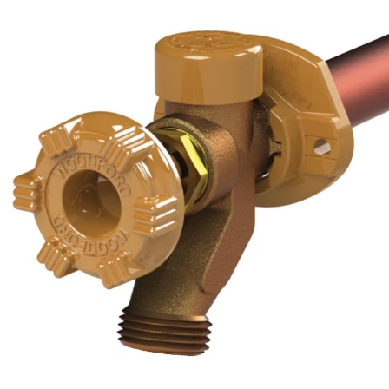
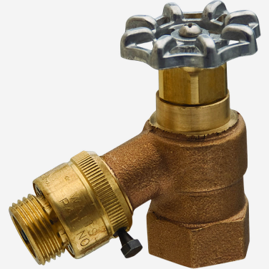
If you have an in-ground sprinkler system with risers near where the supply lines meet the irrigation system, you might have anti-siphon zone valves. This is an Atmospheric Vacuum Breaker (AVB). These are not testable devices.
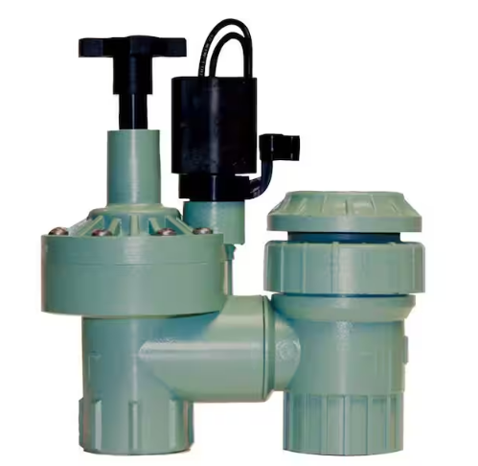

The next level of protection is a pressure vacuum breaker.
This device requires annual testing by a 3rd party.
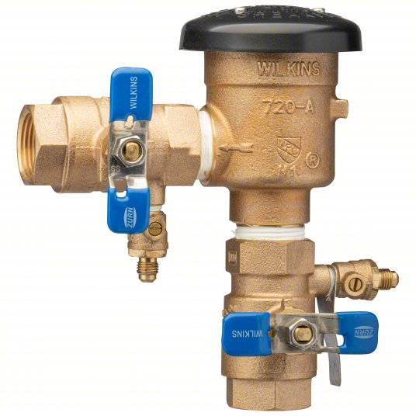
If you have a higher level of backflow prevention, you might have a double check backflow preventer that is installed in-ground. These are often located adjacent to the water meter in a separate box.
This device requires annual testing by a 3rd party.
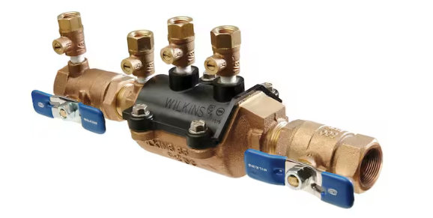
Another type of backflow prevention device is the reduced pressure assembly. It may also be referred to as RPZ for reduced pressure zone. This unit must be installed above ground (cannot be submerged) and protected from freezing. This unit offers a high degree of protection against back pressure and back siphonage conditions.
This device requires annual testing by a 3rd party.
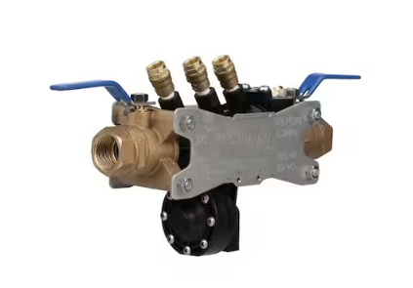

Barlow Water does not recommend any testing company or individual.
For our customers’ convenience we are including an alphabetical list of testers who serve this area along with a link to Oregon Health Authority’s registry of certified testing companies across Oregon.

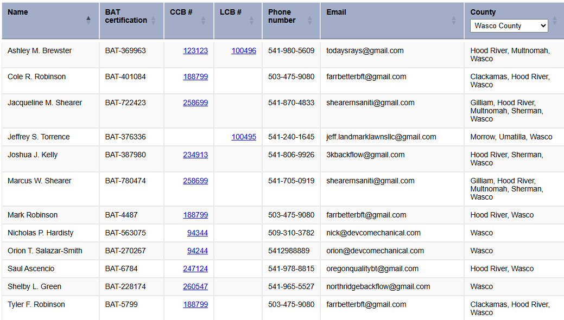
Additionally, Barlow Water is affiliated with:
Epic Water Solutions, 541-233-8817.
Epic Water Solutions is the certified testing company we use for our backflow assembly testing.
Customer Notification: June 2026
Test Results Due: August 1, 2026
Please have your testing company submit test results to: backflow@barlowwateror.gov

